|  |
| --- |
| ECONOMICAL MOBIWISE INSIGHT SYSTEM (EMWIS) |
| Software Design Specification - Report |

## Modular Decomposition

The decomposition of the project is as the following three modules,

* Mobile Recommendations and AJAX
* AI and Cloud Integration
* Cart and Order Management

### Module I: Mobile Recommendations and AJAX

**Task 1: Dynamic Search**  
This task involves implementing a dynamic search functionality where user login and signup are enabled with session tracking to ensure personalized experiences. Password reset and credential recovery flows are managed securely to enhance user accessibility. Additionally, user last login times and device information are recorded to optimize future interactions.

**Task 2: Recommended Mobiles**  
Under this task, mobiles are recommended based on user search patterns and filter behavior. Personalized mobile suggestions are dynamically displayed on the homepage to assist users in quick decision-making. The recommendation engine is continuously updated with new user preferences and behavior patterns to maintain relevance.

**Task 3: Multi-Level Filtering**  
This task focuses on enabling users to filter mobiles based on multiple attributes like brand, price range, and specific features. The system supports dynamic multi-category filters through AJAX to provide real-time results. Optimization strategies are employed to ensure fast response times, thereby improving overall user experience.

**Task 4: AJAX Request Handling**  
Under this task, all live AJAX requests are processed for dynamic search updates, ensuring that user queries are handled seamlessly without page reloads. Additionally, any errors or timeouts are managed gracefully to prevent disruptions. Security measures are incorporated to validate and authenticate AJAX endpoints effectively.

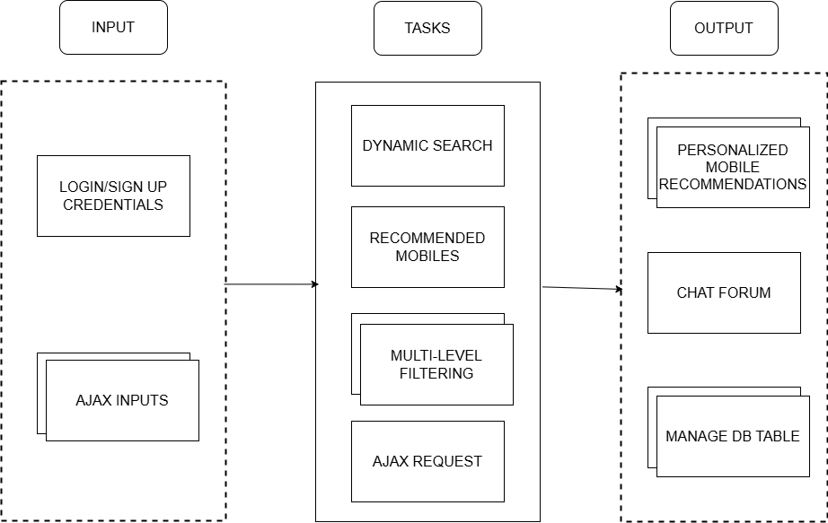

Fig 2.1: Mobile Recommendations and AJAX Task Diagram

**Sample Output:**

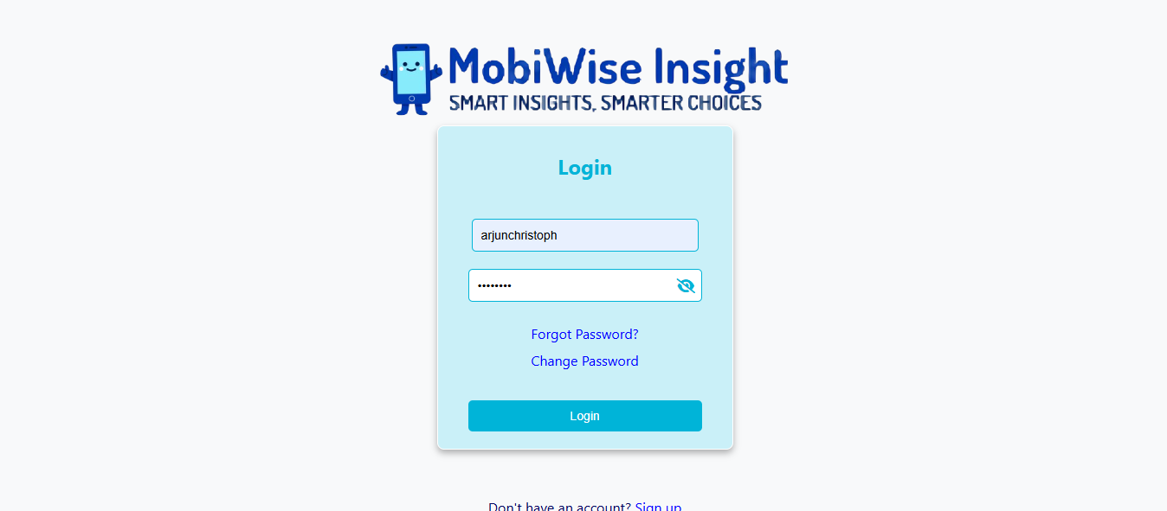

Fig 2.2: Login Form

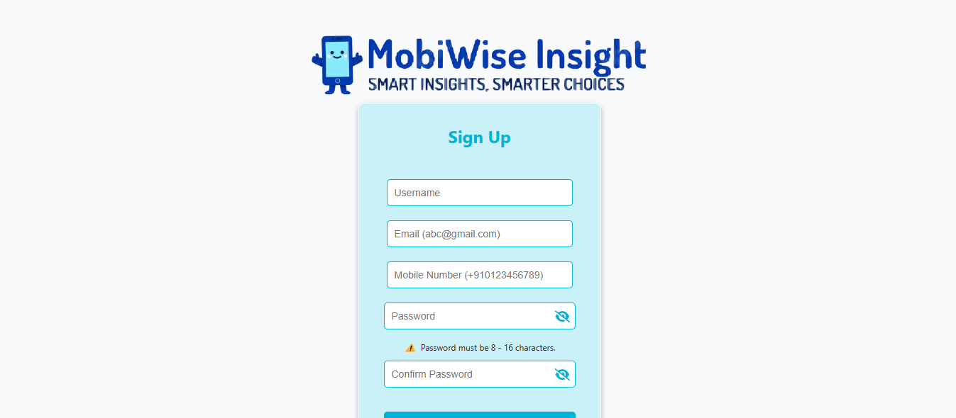

Fig 2.3: Sign Up Form

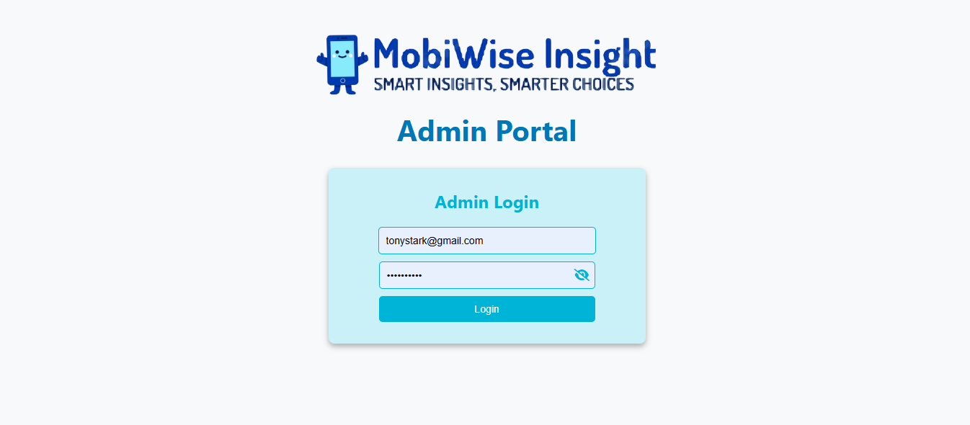

Fig 2.4: Admin Authentication Form

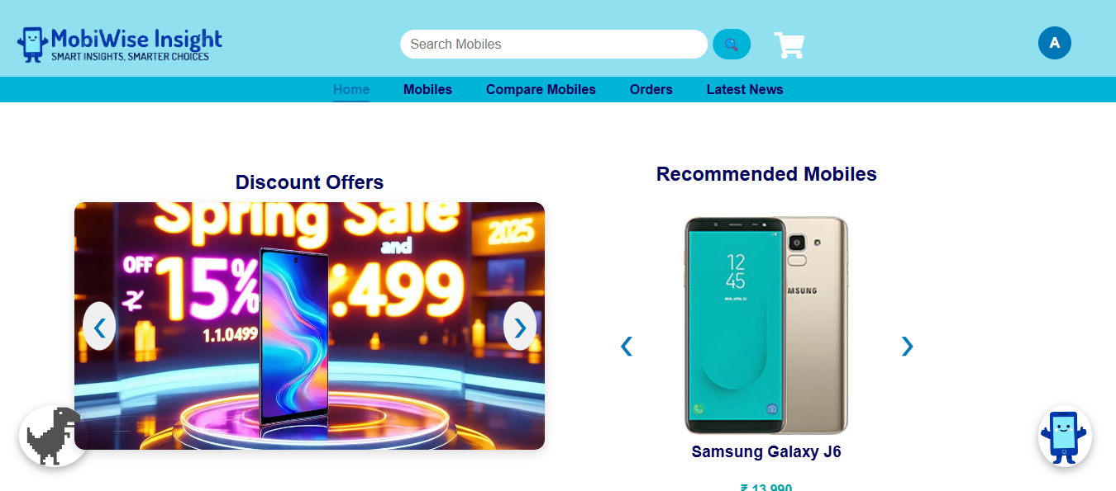

Fig 2.5: Home Page

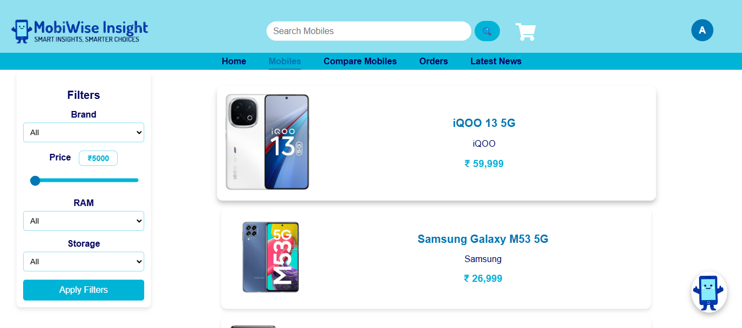

Fig 2.6: Mobile Search Page

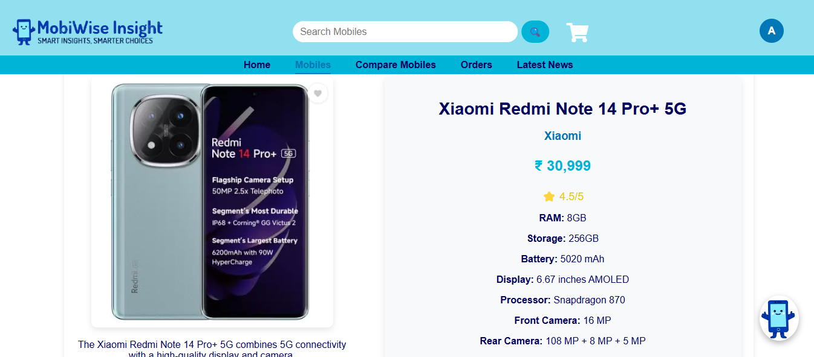

Fig 2.7: Mobile Specifications

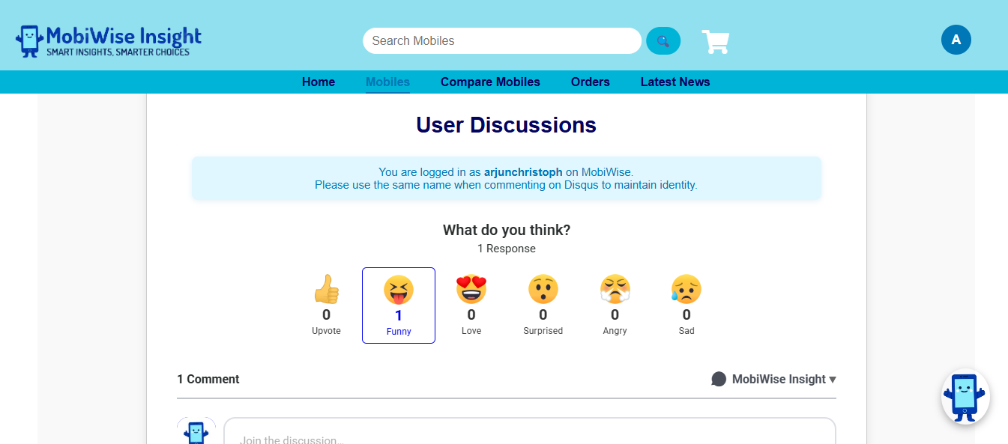

Fig 2.8: User Discussion Forum

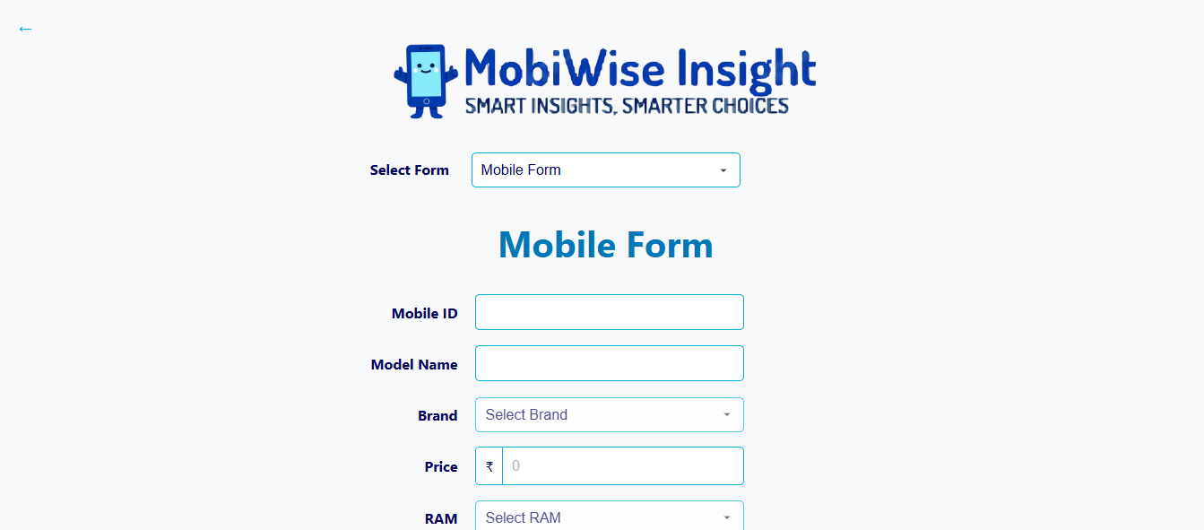

Fig 2.9: Mobile Form

### Module II: AI and Cloud Integration

**Task 1: Mobile Comparison**  
This task involves capturing and analyzing user mobile preferences to generate effective comparisons. Comparative analysis of mobile features is performed, and dynamic comparison links are created for easy sharing and decision support among users.

**Task 2: Chat Bot**  
The chatbot captures chat messages from users seeking mobile assistance. It processes these messages to recognize user intents and recommend suitable mobiles dynamically. Additionally, it manages chatbot replies for frequently asked questions (FAQs) and common troubleshooting queries.

**Task 3: Interactive Game**  
An interactive mobile-themed game module is developed to engage users in a fun and rewarding manner. Game achievements and leaderboard standings are stored in the cloud, allowing users to track their progress. Based on the game performance, promotional rewards or offers are displayed dynamically.

**Task 4: Cloud Integration**  
Cloud integration ensures that mobile comparisons, chat histories, and game data are securely stored in the cloud. It also involves fetching daily mobile news insights from APIs such as NewsAPI, GNews, or Currents and displaying them in the application. Synchronization mechanisms ensure real-time data consistency across all modules.

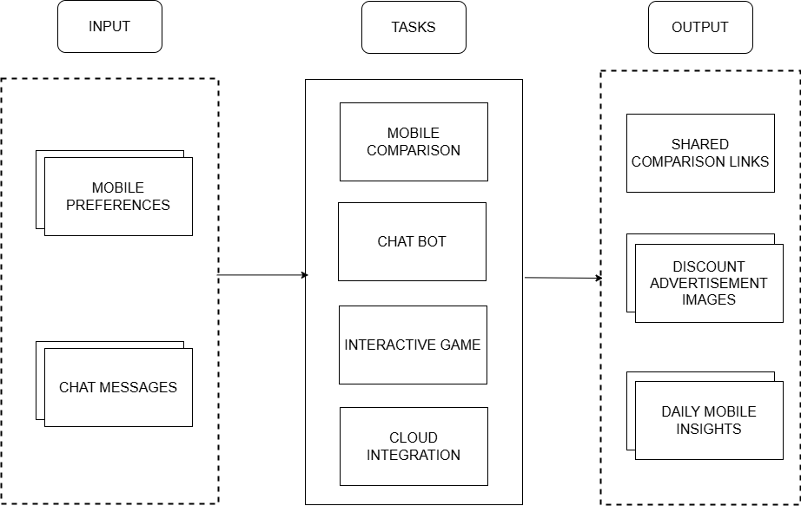

Fig 2.10: AI and Cloud Integration Task Diagram

**Sample Output:**

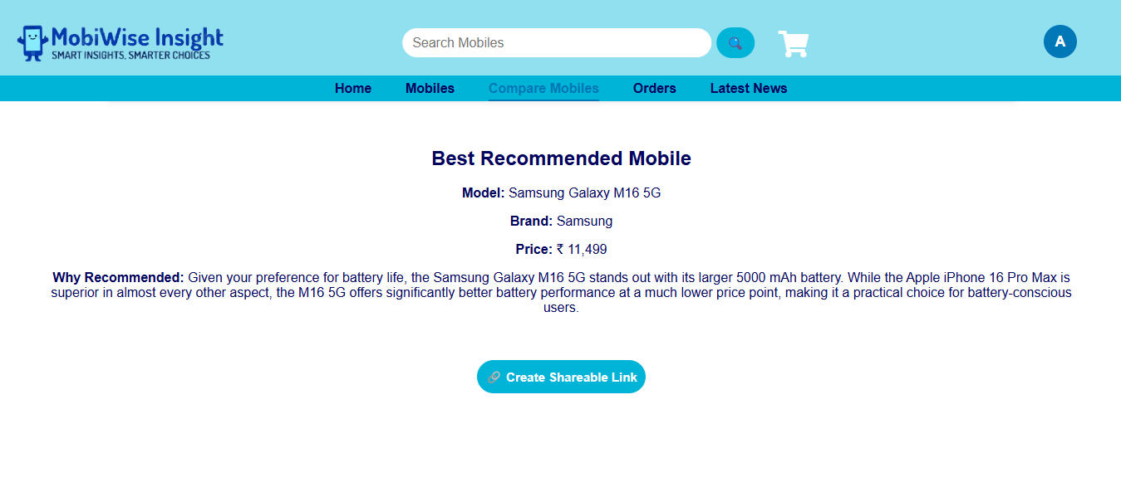

Fig 2.11: Mobile Comparison Result

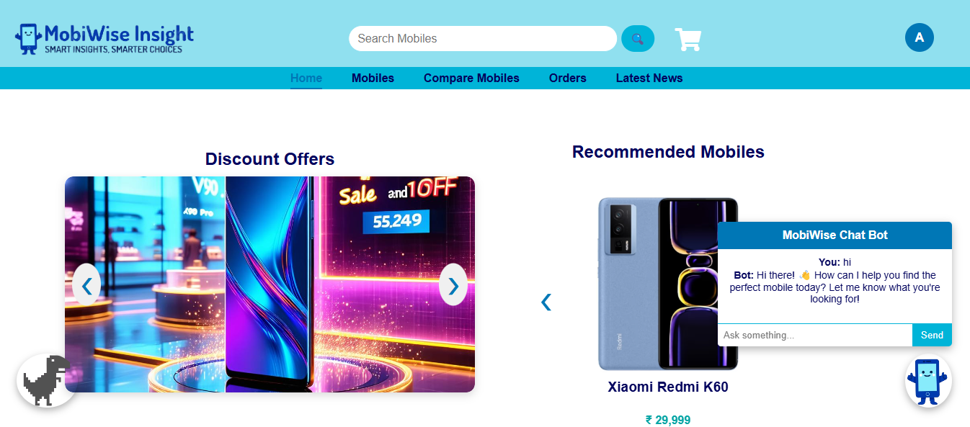

Fig 2.12: Chat Bot



Fig 2.13: AI generated Mobile Discount Advertisements

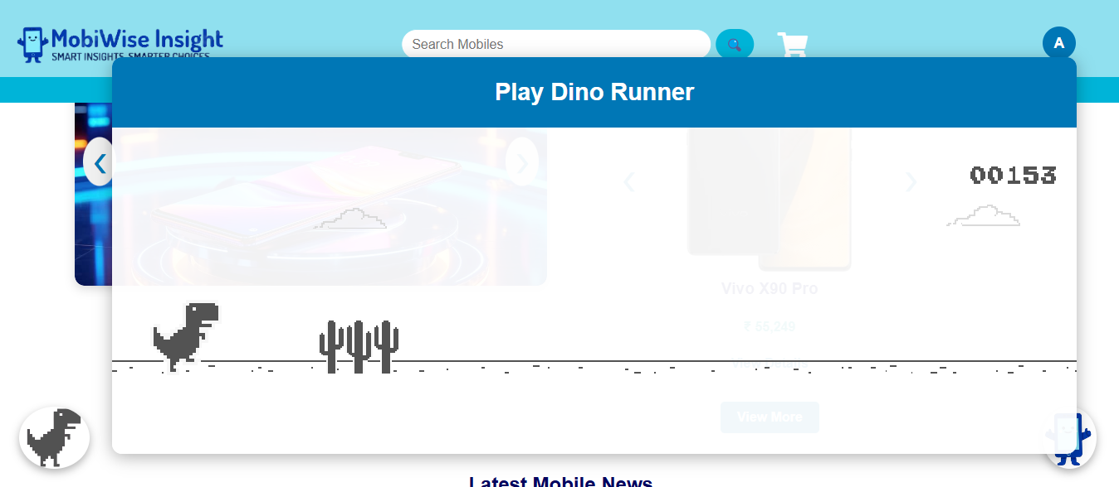

Fig 2.14: Dino Runner Game

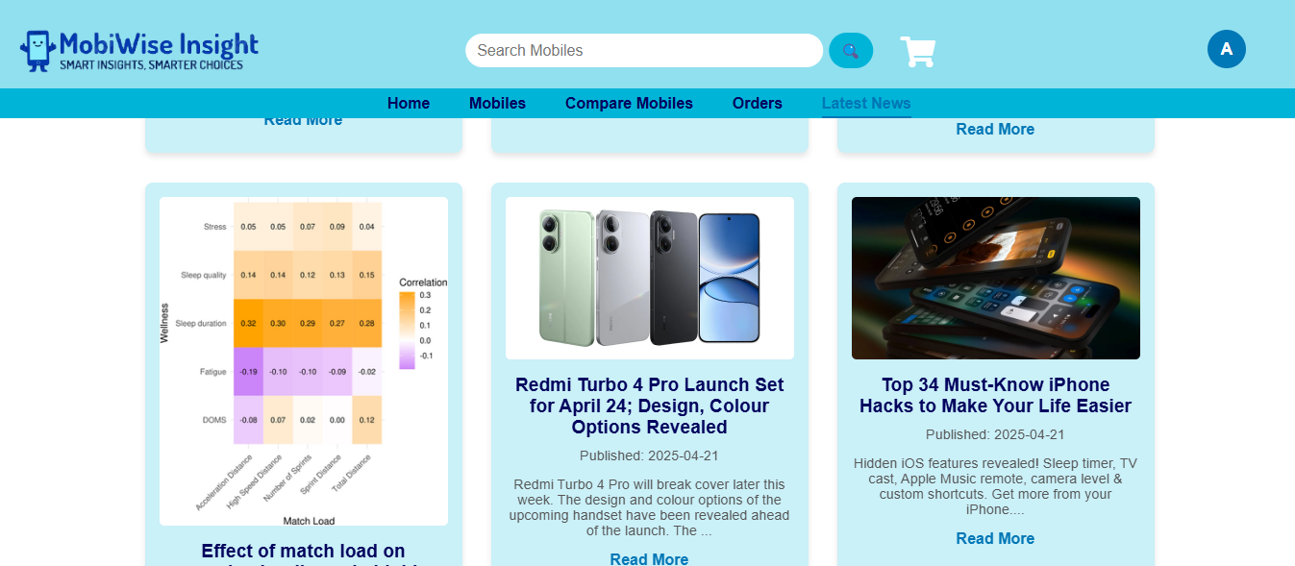

Fig 2.15: Latest Mobile News

### Module III: Cart and Order Management

**Task 1: Cart Management**  
Users can add, update, and remove mobiles from their cart through a simple and intuitive interface. The cart also allows quantity management and preference settings for selected items. Persistent storage ensures that a user's cart is saved even after logging out, provided they are logged in.

**Task 2: Checkout**  
During checkout, user address details are captured securely to facilitate billing and shipping processes. Order confirmation and payment gateway integrations are handled smoothly, ensuring minimal friction. Additionally, user information is validated before final order placement to avoid errors.

**Task 3: Track Order**  
This task allows users to view live status updates regarding their placed orders, from processing to delivery. Notifications about order confirmation, shipping, and delivery stages are sent to the users. In case of any delays or issues, real-time notifications are triggered to keep the user informed.

**Task 4: Order History**  
The order history module maintains detailed records of all past mobile orders made by the user. It provides the option to generate invoices for completed purchases. Additionally, users are given a quick reorder option, allowing them to conveniently purchase the same mobile again.

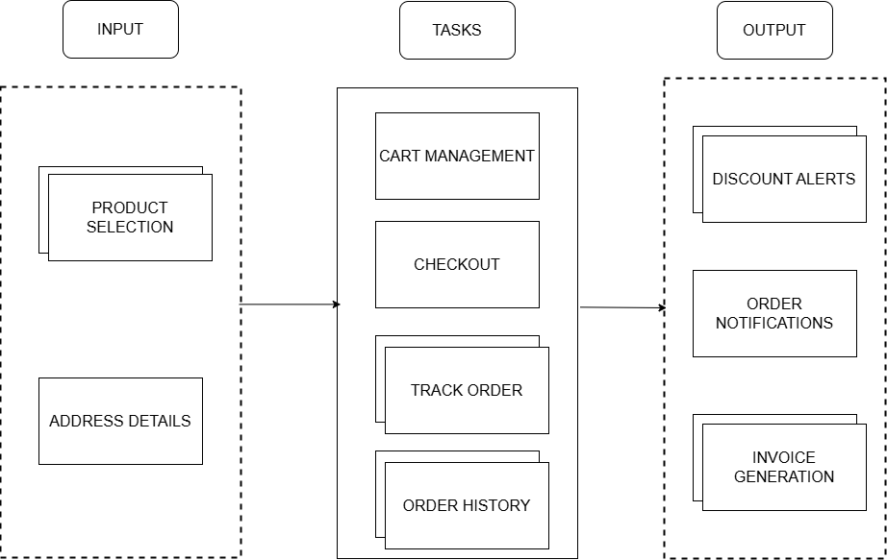

Fig 2.16: Cart and Order Management Task Diagram

**Sample Output:**

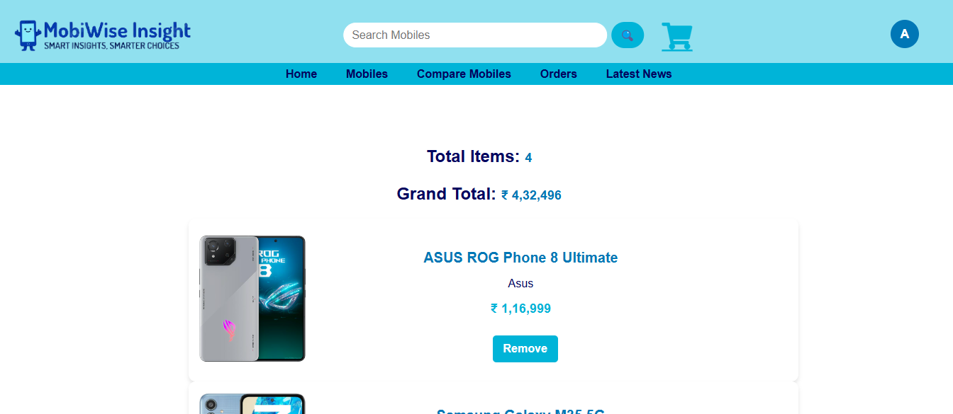

Fig 2.17: Cart System

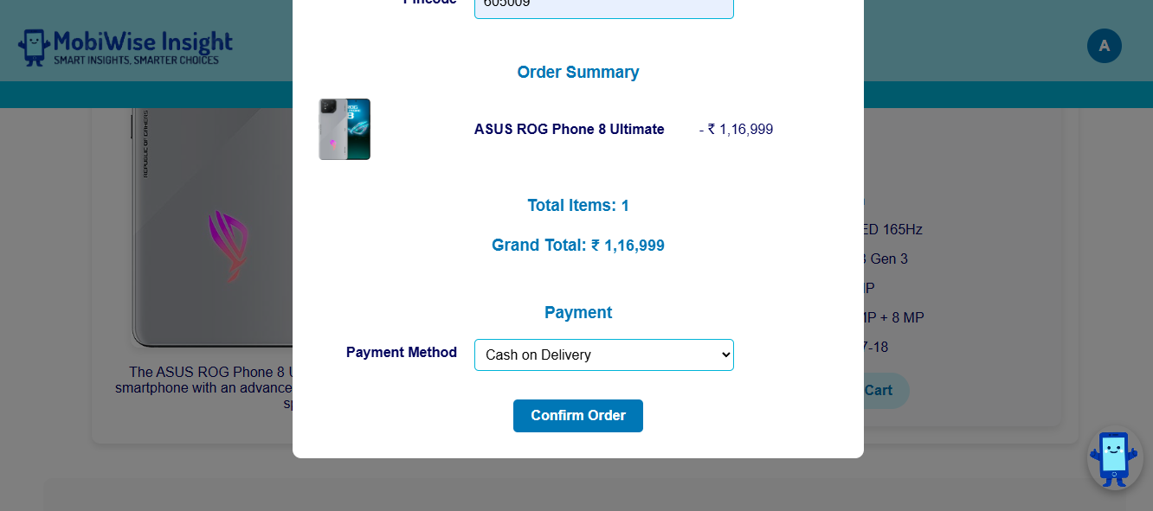

Fig 2.18: Checkout Form

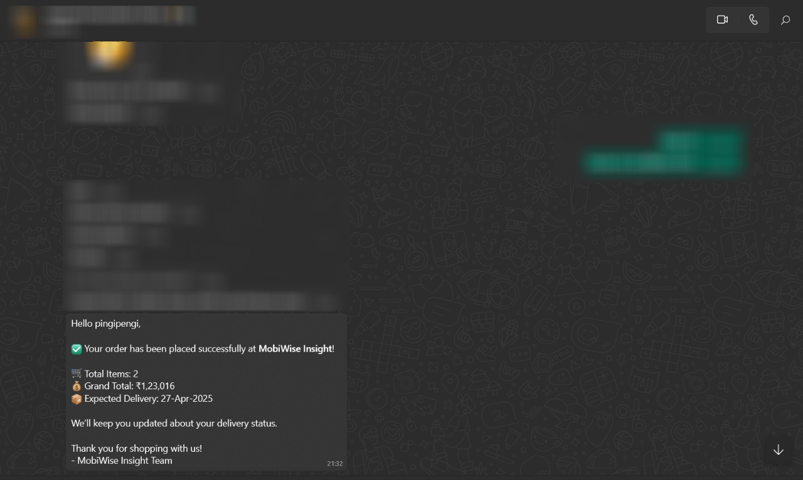

Fig 2.19: Order Confirmation WhatsApp Message

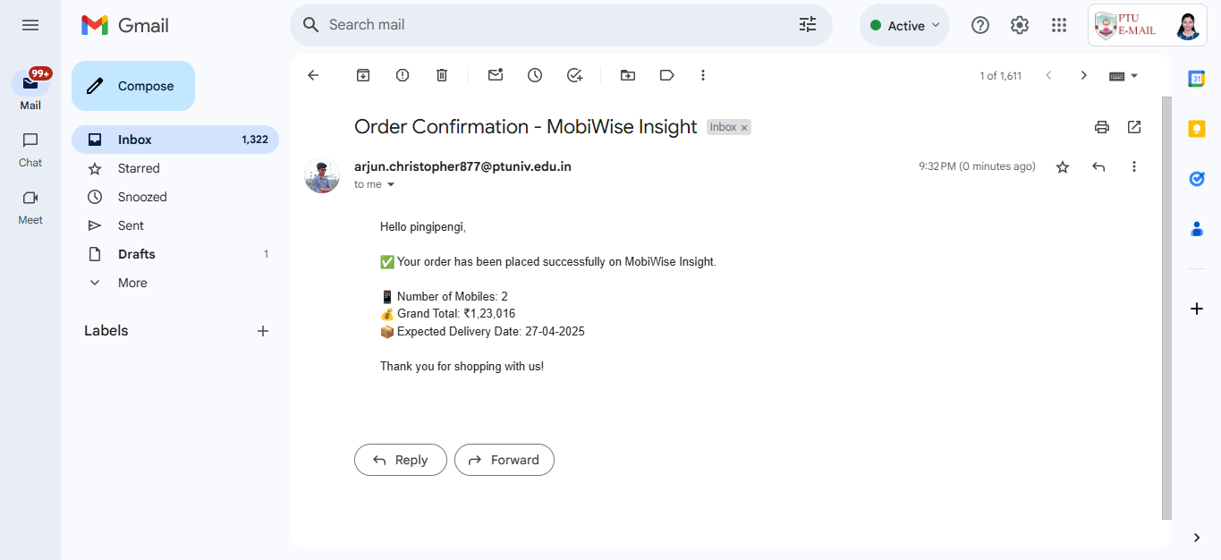

Fig 2.20: Order Confirmation Email

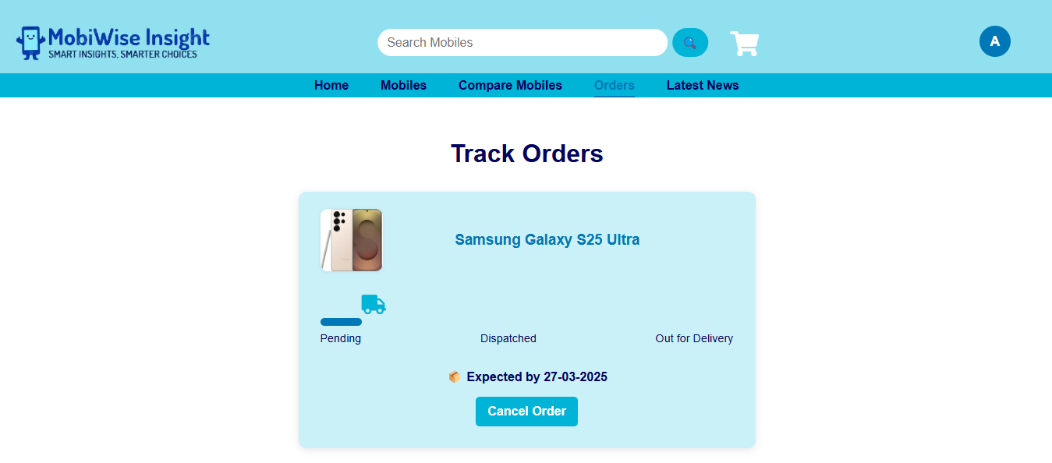

Fig 2.21: Order Tracking

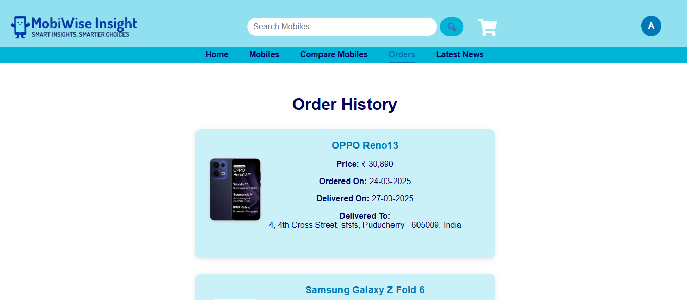

Fig 2.22: Order History



Fig 2.23: Order Invoice

## UML Diagram

### Use Case Diagram

The **Use Case Diagram** provides a high-level visualization of the interactions between the different users and the core functionalities of the **EMWIS**.  
It represents the major system actors, namely the **User** and the **Administrator**, and illustrates how they interact with various system components.

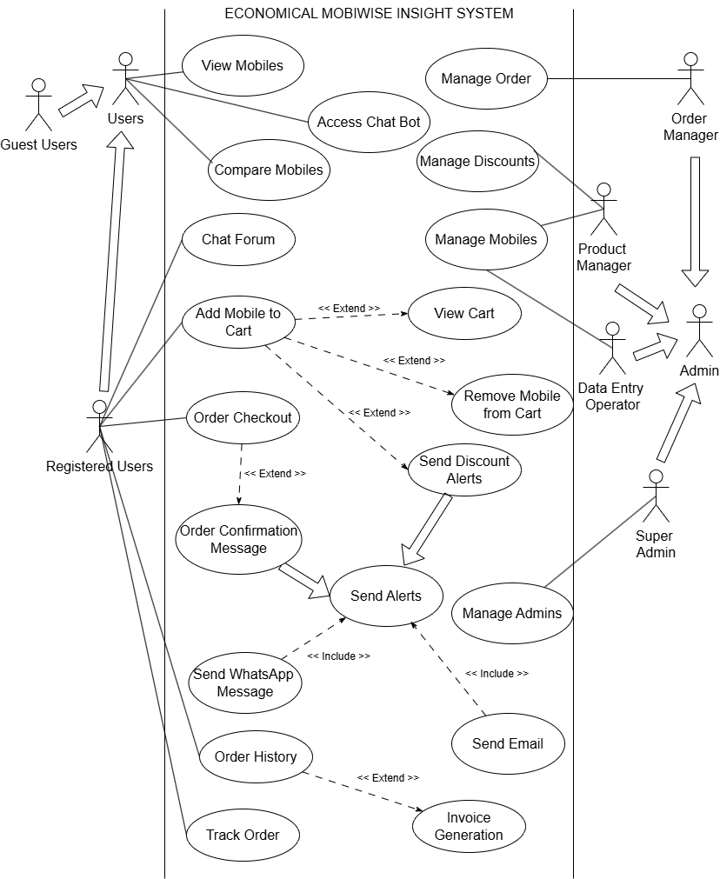

Fig 2.24: Use Case Diagram - EMWIS